AUTHOR

SHUBHAM SINGH

HOME-LLC-ASSESSMENT

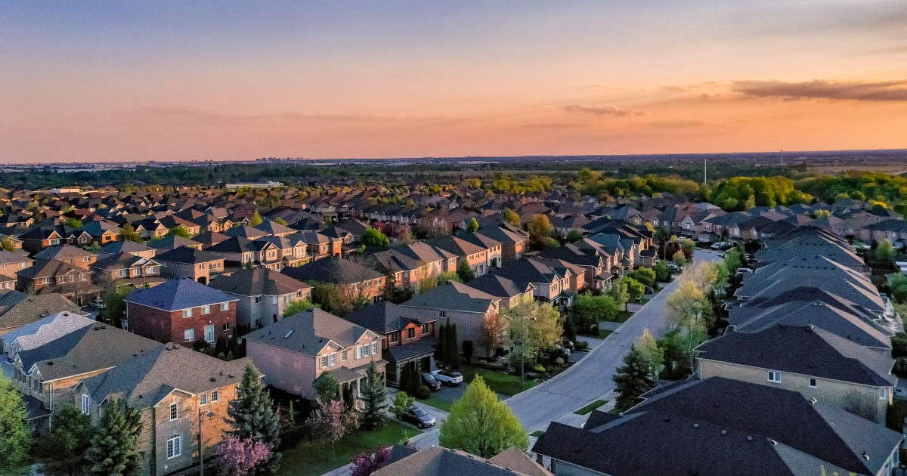

**FACTOR AFFECTING**

**USA – HOUSE PRICES**

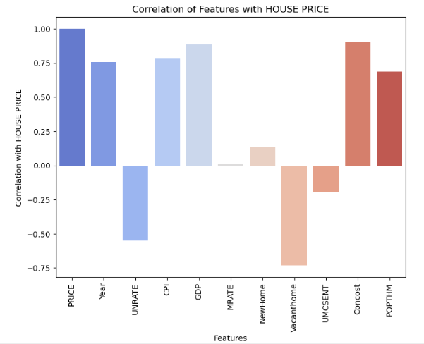

**Correlation Analysis between Key Factors**

### Summary of Correlation Analysis between Key Factors and House Prices

### Negative Correlation

* **Unemployment Rate:** When there are more people without jobs, it usually means people might struggle to buy houses. High unemployment often brings house prices down because fewer people can afford to buy homes.
* **Vacant Houses:** Having lots of empty houses means there's too much supply and not enough demand. This can push house prices down because sellers might lower prices to attract buyers.
* **Mortgage Rate:** Expensive loans (higher mortgage rates) mean fewer people can afford to borrow money for a home. High rates might make people hesitate to buy, potentially slowing down house price growth.
* **Consumer Sentiment:** Low confidence in the economy might make people hold off on big purchases like houses, affecting how much they're willing to pay.

### Positive Correlation

* **CPI (Cost of Living):** When the overall cost of things goes up (inflation), including groceries, gas, etc., it often means houses might become more expensive too.
* **GDP (Economic Health):** A strong economy (higher GDP) can lead to an increase in house prices as people feel more confident and have more money to spend.
* **Monthly New House Construction:** More new houses mean more choices for buyers. But too many new houses and not enough buyers could lead to price drops.
* **Construction Costs:** Higher building expenses might lead to higher house prices as builders charge more to cover costs.
* **Population Trends:** More people moving in usually means higher demand for houses, potentially leading to higher prices.

1. **FACTOR AFFECTING HOUSE PRICES.**
   1. **Unemployment VS House Price.**

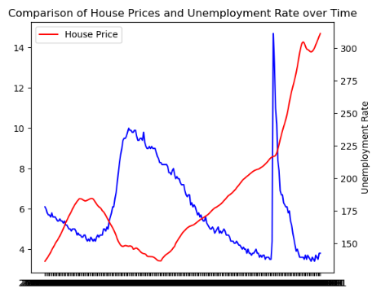

The relationship between unemployment and house prices in the USA has shown a distinct correlation, where high unemployment often corresponds to lower house prices. However, amid the recent economic shifts, particularly during the height of the COVID-19 pandemic, this correlation seemed to diverge. When unemployment rates soared, reaching unprecedented levels, the housing market surprisingly saw a surge in prices. Despite the high unemployment figures, house prices continued to rise. Now, as unemployment rates have gradually declined, the housing market has sustained its momentum with prices remaining notably high. This anomaly defied the traditional inverse relationship between unemployment and house prices, indicating various factors at play, such as government stimulus measures, low mortgage rates, and shifting buyer preferences, which collectively contributed to this unique market scenario.

* 1. **CPI VS HOUSE PRICES**

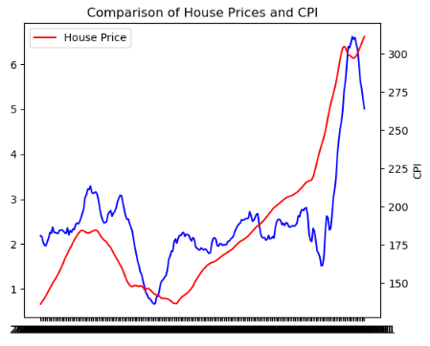

The relationship between the Consumer Price Index (CPI) and prices, particularly in the housing market, traditionally suggests a connection where high CPI corresponds to higher prices and vice versa. However, recent market dynamics have presented an intriguing anomaly. Despite a decrease in the CPI, indicating relatively low inflation rates, prices in certain sectors, notably housing, have remained persistently high. This divergence from the conventional correlation between CPI and prices challenges the expected pattern. Despite the CPI reflecting lower inflationary pressures, housing prices have sustained their upward trajectory. This phenomenon suggests that various other influential factors, such as limited housing supply, increased demand, historically low mortgage rates, and speculative investment, are significantly outweighing the impact of CPI on the housing market. These factors collectively contribute to the ongoing paradox where, despite a downtrend in CPI, prices, especially in the housing sector, have continued to soar.

* 1. **GDP VS HOUSE PRICES**

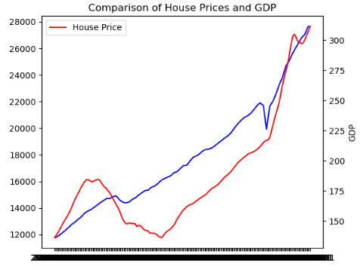

The relationship between a nation's Gross Domestic Product (GDP) and prices, particularly within the housing market, often reflects a certain level of correlation. As the GDP of a nation experiences growth and moves positively, it tends to stimulate economic activity, leading to increased consumer spending, business investments, and overall confidence in the market. This surge in economic activity commonly intertwines with a rise in housing demand. Consequently, when GDP is back on track and shows sustained growth, it frequently correlates with an upward trend in house prices. This pattern arises from heightened consumer optimism and purchasing power, leading to a greater demand for homes. Recent instances where GDP has rebounded or shown consistent growth have often coincided with periods of escalated house prices, underscoring the interplay between economic expansion and the flourishing housing market.

**1.4 Mortgage Rates VS House Price.**

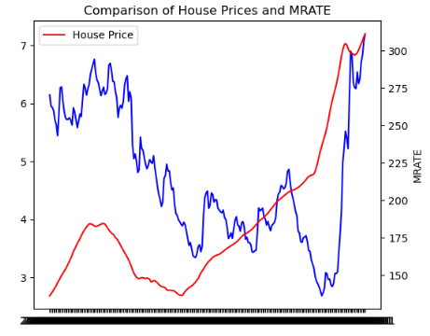

The relationship between mortgage rates and house prices often follows an inverse pattern—when mortgage rates increase, there tends to be a downward pressure on house prices. Higher mortgage rates mean increased borrowing costs for potential homebuyers, which can decrease their purchasing power. Consequently, this decrease in affordability typically leads to reduced demand for homes, thereby potentially causing decline in house prices.

However, recent trends have shown a departure from this traditional relationship. Despite mortgage rates being higher, house prices have continued to rise. This divergence suggests that other influential factors, such as supply shortages, robust demand driven by demographic shifts or limited inventory, and fierce competition among buyers, are outweighing the impact of higher mortgage rates on house prices. These factors collectively contribute to the counterintuitive scenario where both mortgage rates and house prices are concurrently high, challenging the usual assumption of a direct inverse relationship between the two variables.

**1.5 Vacant House VS House Price.**

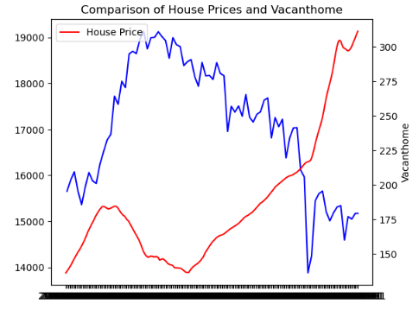

The availability of vacant houses in the real estate market often plays a significant role in influencing house prices. When there's a surplus of vacant houses, it typically creates a scenario where supply exceeds demand, putting downward pressure on prices. However, if the number of vacant houses decreases, it often leads to a more balanced or constrained supply, potentially resulting in increased competition among buyers and a subsequent rise in house prices.

Recent trends have indicated a reduction in the number of vacant houses available in the market. This decline in vacancies could be contributing to the buoyancy of house prices. With a decrease in the surplus inventory of houses, the market might be experiencing a shift towards a more equilibrium state where demand is meeting a tighter supply. Consequently, this reduced availability of vacant houses might be a contributing factor to the sustained or rising house prices observed in the current real estate landscape.

**1.6 New House VS House Price.**

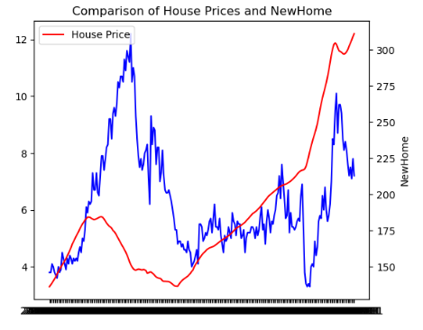

The availability of new houses in the real estate market also significantly influences house prices. When there's a shortage of new houses entering the market, it often leads to a constrained supply. This limited supply can create a scenario where demand outweighs available inventory, potentially resulting in increased competition among buyers and an upward pressure on house prices.

Recent trends have shown a decrease in the number of new houses being introduced to the market. This decline in new housing inventory might be contributing to the persistent or rising house prices. With fewer new houses available, the market may be experiencing a situation where the demand for housing surpasses the supply of newly constructed homes. Consequently, this scarcity of new housing options might be a contributing factor to the sustained or increasing house prices observed in the current real estate landscape.

**1.7 Consumer Sentiment VS House Prices.**

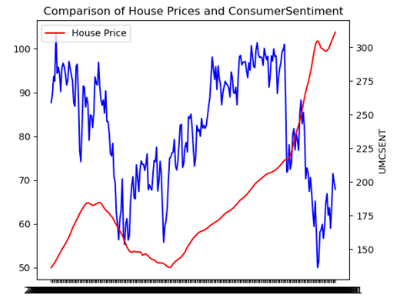

Consumer sentiment, reflecting public perception and confidence in the economy, does play a role in influencing housing market dynamics. When consumer sentiment decreases, it can signal caution or uncertainty among potential homebuyers. This cautious sentiment may lead to reduced willingness to make significant financial commitments, potentially impacting housing demand and subsequently affecting house prices.

However, recent market behavior has shown an interesting divergence from this traditional correlation between consumer sentiment and house prices. Despite a decline in consumer sentiment, where individuals might express concerns about economic conditions or future prospects, house prices have remained notably high. This divergence suggests that other overriding factors, such as supply shortages, historically low mortgage rates, demographic shifts, and pent-up demand, are exerting stronger influences on the housing market than the downturn in consumer sentiment. These factors collectively contribute to the unexpected scenario where, despite a decrease in consumer confidence, house prices persist at elevated levels, showcasing the complexity and resilience of the real estate market amid shifting sentiments.

**1.8 Construction costs VS House Prices.**

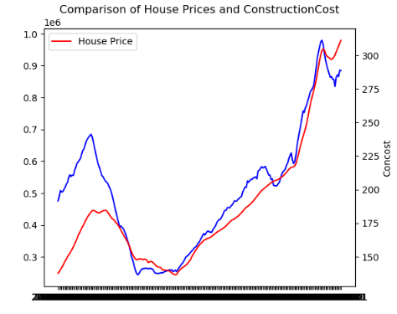

Rising construction costs often exert significant influence on the pricing of new homes. When expenses for materials, labor, and regulatory compliance surge, builders tend to reflect these increased costs in the selling price of newly constructed houses. This escalation in construction expenses frequently translates into higher prices for new homes, impacting the affordability and overall pricing dynamics within the housing market. However, the direct impact of these rising construction costs on existing home prices can be more nuanced, as existing house prices are influenced by a myriad of factors beyond construction expenses, including market demand, supply, and economic conditions.

1. **CONCLUSION.**

## Conclusion from the Project Analysis:

The analysis reveals distinct correlations between key factors and housing prices in the US:

**Positive Correlations:**

* **Consumer Price Index (CPI), GDP, Construction Costs, and Population:** These factors exhibit positive correlations with housing prices. When CPI and GDP increase, housing prices tend to rise. Similarly, an increase in construction costs and population coincides with an upward trend in housing prices.

**Negative Correlations:**

* **Unemployment Rate, Vacant Houses, Mortgage Rates, and Consumer Sentiment:** These factors demonstrate negative correlations with housing prices. Higher unemployment, increased vacancy rates, elevated mortgage rates, and lower consumer sentiment correspond to decreased housing prices. Notably, during times of high unemployment, housing prices tend to decrease due to reduced demand.

**Recent Trends:**

* Despite recent low CPI trends, housing prices remain high, indicating a deviation from the typical CPI-house price relationship. Similarly, while mortgage rates are high, housing prices have remained elevated, diverging from the anticipated impact of high mortgage rates on purchasing behavior.
* Decreasing vacant houses in recent times have contributed to higher housing prices. The reduced availability of new houses in the market has also elevated housing prices, contrary to the historical trend where an increased supply lowered prices.
* Although traditionally, high consumer sentiment aligned with increased housing prices, recent market conditions have seen high prices persist even with lower consumer sentiment.

**Impact of Construction Costs:**

* The analysis emphasizes a significant positive impact of higher construction costs on housing prices. As construction costs rise, housing prices tend to follow suit.

**Population Dynamics:**

* While historically population dynamics did not exhibit a substantial effect, recent increases in population have contributed to a rise in housing prices.

The observed trends provide valuable insights into the intricate relationship between economic indicators, market sentiments, and their collective influence on housing prices. These findings underscore the nuanced dynamics shaping the housing market.

1. **REFFRENCE**

DATA LINK AND DISCRIPTION

1. Unemployment rate - <https://fred.stlouisfed.org/series/UNRATE>

The unemployment rate represents the number of unemployed as a percentage of the labor force. Labor force data are restricted to people 16 years of age and older, who currently reside in 1 of the 50 states or the District of Columbia, who do not reside in institutions (e.g., penal and mental facilities, homes for the aged), and who are not on active duty in the Armed Forces

1. **Fixed Rate Mortgage -** <https://fred.stlouisfed.org/series/MORTGAGE30US>

Freddie Mac, 30-Year Fixed Rate Mortgage Average in the United States [MORTGAGE30US], retrieved from FRED, Federal Reserve Bank of St. Louis; <https://fred.stlouisfed.org/series/MORTGAGE30US>, December 9, 2023.

1. **S&P/Case-Shiller U.S. National Home Price Index -** <https://fred.stlouisfed.org/series/CSUSHPISA>

S&P Dow Jones Indices LLC, S&P/Case-Shiller U.S. National Home Price Index [CSUSHPISA], retrieved from FRED, Federal Reserve Bank of St. Louis;

1. **Average Sales Price of Houses Sold for the United States -** <https://fred.stlouisfed.org/series/ASPUS>

U.S. Census Bureau and U.S. Department of Housing and Urban Development, Average Sales Price of Houses Sold for the United States [ASPUS], retrieved from FRED, Federal Reserve Bank of St. Louis;

<https://fred.stlouisfed.org/series/ASPUS>, December 9, 2023.

1. **Consumer Price Index: All Items: Total for United States (USACPALTT01CTGYM) -** <https://fred.stlouisfed.org/series/USACPALTT01CTGYM>
2. **Gross Domestic Product (GDP) -** <https://fred.stlouisfed.org/series/GDP>
3. **Monthly Supply of New Houses in the United States -** <https://fred.stlouisfed.org/series/MSACSR>
4. **Housing Inventory Estimate: Vacant Housing Units in the United States (EVACANTUSQ176N)-**<https://fred.stlouisfed.org/series/EVACANTUSQ176N>
5. **New Privately-Owned Housing Units Authorized in Permit-Issuing Places: Total Units (PERMIT) -** <https://fred.stlouisfed.org/series/PERMIT>
6. **University of Michigan: Consumer Sentiment -** <https://fred.stlouisfed.org/series/UMCSENT>
7. **Median Sales Price of Houses Sold for the United States (MSPUS) -** <https://fred.stlouisfed.org/series/MSPUS>
8. **Real Median Household Income in the United States -** <https://fred.stlouisfed.org/series/MEHOINUSA672N>
9. **Total Construction Spending: Residential in the United States -** <https://fred.stlouisfed.org/series/TLRESCONS>
10. **Population (POPTHM) -** <https://fred.stlouisfed.org/series/POPTHM>
11. **15-Year Fixed Rate Mortgage Average in the United States-** <https://fred.stlouisfed.org/series/MORTGAGE15US>
12. **Housing Inventory Estimate: Total Housing Units in the United States (ETOTALUSQ176N)-** <https://fred.stlouisfed.org/series/ETOTALUSQ176N>
13. **Existing Home Sales: Months Supply (HOSSUPUSM673N)-** <https://fred.stlouisfed.org/series/HOSSUPUSM673N>
14. **Monthly Supply of New Houses in the United States (MSACSR) -** <https://fred.stlouisfed.org/series/MSACSR>
15. **Median Sales Price for New Houses Sold in the United States (MSPNHSUS)-** <https://fred.stlouisfed.org/series/MSPNHSUS>
16. **Median Sales Price of Existing Homes (HOSMEDUSM052N)-** <https://fred.stlouisfed.org/series/HOSMEDUSM052N>
17. **Sticky Price Consumer Price Index less Food and Energy (CORESTICKM159SFRBATL)-** <https://fred.stlouisfed.org/series/CORESTICKM159SFRBATL>
18. **New One Family Houses Sold: United States (HSN1F)-** <https://fred.stlouisfed.org/series/HSN1F>
19. **Homeownership Rate in the United States (RHORUSQ156N) -** <https://fred.stlouisfed.org/series/RHORUSQ156N>
20. **Housing Affordability Index (Fixed) (FIXHAI) -** <https://fred.stlouisfed.org/series/FIXHA>